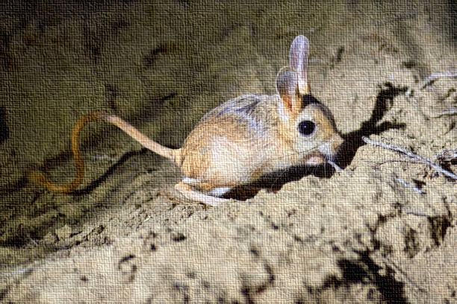Timetree Aquaporin Activity Page

Timetree of Life exercise (grades 7-12)

*Objective:* Since AQPs are ubiquitous throughout the tree of life. Students can go to the Timetree of life database to find when a particular desert animal diverged with its non-desert counterpart: <http://www.timetree.org/>

Before using Timetree, students can pick 2 animals they think might have different water needs and adaptations but are closely related. Students will search for any research on aquaporins and the organism and look for articles that discuss the adaptation. Key words for searches are “aquaporins, diversity, and evolution,” along with the specific animal’s name.

Students will work in pairs to read the article and find any information about the AQP protein as it relates to the organism’s adaptation

They can then compare the divergence times of those organisms. Let us take the example of rodents.

*Example:* Rodents have desert species, mountainous species, and wetland species.

Students find articles:

*“Aquaporins in Desert Rodent Physiology”* <https://www.journals.uchicago.edu/doi/pdf/10.1086/BBLv229n1p120>

Students may not be able to find articles on all the animals they compare, but they can compare the divergence times of the desert rodent like the Jerboa (jumping mouse) to the common field mouse in the Timetree database.

After finding the divergence times students can answer the following questions:

1. Why would aquaporins in desert mice need to be different from a field mouse?
2. By what process do you think allowed desert mice to achieve the adaptation of the aquaporin?
3. What is the divergence time of the Jerboa and the field mouse?
4. Who is older?
5. Speculate: What caused the split, was it geographical? Climate? Migration?
6. What are some of the other phenotypic appearances and adaptations of dessert animals like the Jerboa?